Reg. No. CODE: RM

PH. D COURSEWORK EXAMINATION, MAY 2023
DEPARTMENT: MANAGEMENT
RESEARCH METHODOLOGY
Time: 03 hours Maximum Marks: 50
Cochi Campus: Liney & Pradeep

Instructions:
- Section A Compulsory
- Answer any four from Section B
- Each question carries 10 Marks

SECTION A
Answer the following question. (10 X 1 = 10)

- A histogram normal plot and a boxplot along with the descriptive statistics of marks out of 30 scored by the students for an examination are given. Write what all interpretations you can make from this
Descriptive Statistics  Marks for Exam  N Valid 18  Missing 0  Mean 19.7778  Median 20.0000  Mode 21.00  Std. Deviation 1.35280  Variance 1.830  Skewness -.349  Std. Error of Skewness .536  Kurtosis -.631  Std. Error of Kurtosis 1.038  Range 5.00  Minimum 17.00  Maximum 22.00  Sum 356.00 | 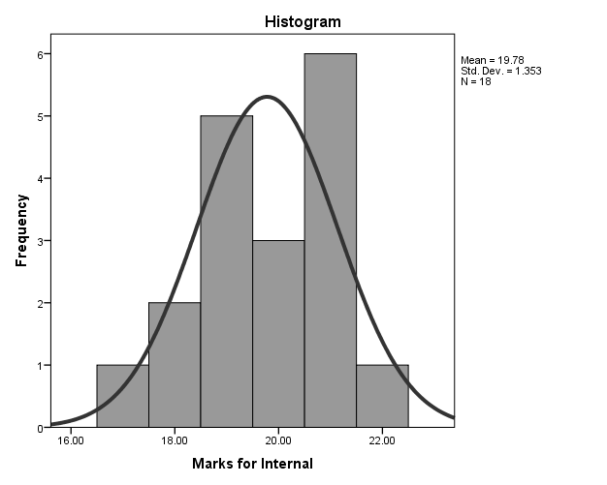
 | 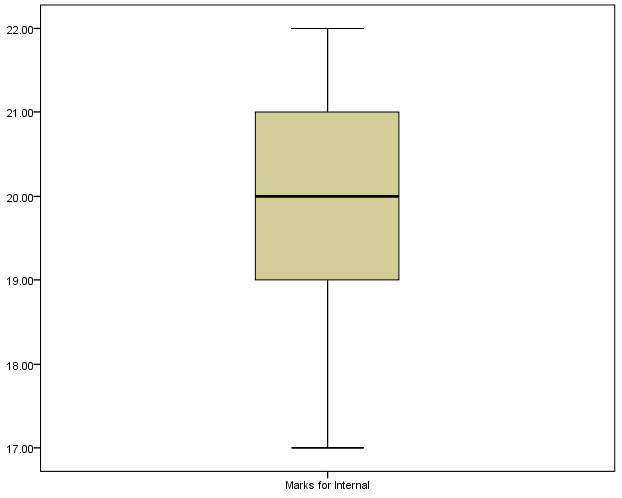

SECTION B

Answer any four from the following questions. (10 X 4 = 40)

2. Perception about Industry 4.O technology was studied using a sampling technique to select 12 blocks, 20 circles and 40 cells from the 4 zones in the state for the study. Data were collected with the aid of structured questionnaires through interview schedules from 144 randomly selected respondents and analysed with descriptive and inferential statistical tools.

a. Comment on the sampling design is used in this study
b. If you were to research on the same topic, how would you have administered the sampling?

3. Please read the case below

Research Problem: Transportation of the highly perishable commodity is hard as they require proper temperature during the transit which can be done by trucks and vans equipped properly. This adds on to the cost for the exporter or processor. Technological advancements are made globally however their usage is not yet fully commenced in Indian perishable food markets. Inadequate storage facilities and transportation can affect the quality of food. Wholesalers find it difficult to afford cost associated with proper facilities for transportation and storage for particular food at large.
Objective:
  - To study about the transportation and storage facilities associated with easily perishable food industry in Kerala.

Question: Explain in detail, the way you execute this study, if you follow an
- Exploratory research design
- Descriptive research design

4. The complex challenges that Kerala faces on the development front are well known. Blessed with nature’s bounty and human development indices comparable to the best in the West, the State has been on an economic upswing thanks to an industrious and cash-rich emigrant population and a thriving, though at times battered, cash crop economy. Rising incomes have led to a boom in the consumer goods and services market. The labour scene has been relatively peaceful of late. A narrow agricultural and industrial production base, acute scarcity of land for big ticket investments and the absence of political consensus on the most suitable development trajectory have all been hampering Kerala’s efforts to embrace new-age development. If the plans unveiled at the ‘Emerging Kerala’ business and investment summit held are implemented, however, the State might well be on its way to finding solutions for these vexing issues.
a) Extract out a research problem from the paragraph above.
b) Formulate appropriate objectives for the identified problem
c) Formulate research questions that are to be addressed

5. Given below are three questions that belong to a questionnaire for finding out readers attitudes for a leading business magazine say “Frontline”. Comment on each question, as to whether changes are required for better understanding by the respondents. Give reasons for your answer.
(a) Do you read “Frontline” regularly?
(b) What percentage of your time is spent on attending meetings in your office?
(c) How much discretionary buying power do you have per year?
6. Generate a sample questionnaire (minimum 15 items for the topic Evaluation of Investor behaviour and investment planning or adoption of Fintech among MSMEs or Effectiveness of AI for Business Performance
a. Provide a checklist of best practices in designing a questionnaire
b. List necessary assumptions & highlight the target audience of your research
c. Write a short note on recommended statistical tools for analysis.

